Jonathan Walker Valvano – one messy office, four fun classes to teach, ten textbooks, the best job on the planet spanning four decades, thousands of mistakes but a few successes, thousands of brilliant students, two hundred thousand on-line students, and millions of YouTube views; lifelong explorer with one mind, one body, one soul, one lovely horse with beautiful spots, two free-spirited cats, countless friends, three wonderful children; always striving to make the world a better place. You can live 40 days without food, 4 days without water, 4 minutes without air, but I wouldn't last 4 seconds without the love and companionship of my friends and family. His soldering iron is currently plugged in at his office at EER 5.820 here at The University of Texas at Austin. Now that this pandemic craziness is over, stop by and say hello. As always, please be safe and take care of each other. History will remember these times, let history remember us well. | 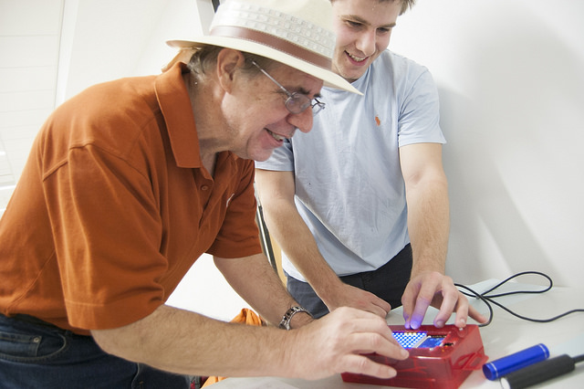
Robot Systems Learning Kit was completely redesigned. The robot is runs on either the TM4C123 or MSPM0 LaunchPad. The ultimate goal of the learning kit is to design, build, and test a robot system capable of solving complex tasks. Example challenges include exploring a maze, and racing autonomously. However, it is not the final robot that matters, but the educational journey that discovers a wide range of engineering principles along the way. Rather than just providing the robot kit and a challenge to solve, this curriculum follows an educational road map that intentionally exposes deep learning along the way. More information on RSLK January 2025 | 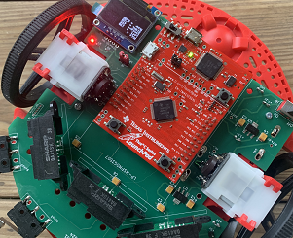

New textbook for learning embedded systems on the MSPM0+.
Introduction to Embedded Systems Using the MSPM0+, ISBN: 979-8852536594, Available from Amazon Architecture, assembly language and C programming for the Texas Instruments MSPM0G3507. See the ECE319K web page for all the details for the LP-MSPM0G3507 Launchpad.
Three textbooks for learning embedded systems on the TM4C123.
Volume 1, Introduction to ARM Cortex-M Microcontrollers (fifth edition, 6th printing- January 2019), ISBN: 978-1477508992, Available from Amazon Available as Kindle book, Lecture and Lab Material, Architecture, assembly language and C programming for the Texas Instruments TM4C123, and TM4C1294.
Volume 2, Real-Time Interfacing to ARM Cortex-M Microcontrollers (ninth printing, July 2024), ISBN: 978-1463590154, Textbook for EE445L, Available from Amazon Kindle e-book Lecture and Lab Material Interfacing and embedded system design for the Texas Instruments TM4C123, and TM4C1294.
Volume 3, Real-Time Operating Systems for ARM Cortex-M Microcontrollers (sixth printing, January 2026), ISBN: 978-1466468863, Textbook for ECE445M, Available on Amazon Lecture and Lab Material Operating systems, signal processing and network design for the Texas Instruments MSPM0, TM4C123, and TM4C1294.
CCS Installation/setup for MSPM0G3507
Step by step instructions
ECE319K Lab 1 with videos
Keil 5 Installation/setup for TM4C123
Keil uVision download and setup version 5
Stellaris Driver Installation Guide for the TM4C123
Download and run MDK_Stellaris_ICDI_AddOn.exe
Creating a Keil 5 project from scratch.
How to install EE319K/EE445L/EE345M software on a Macintosh
Troubleshooting the Keil/TM4C123 debugger
Keil real-board debugger used to work, now it quits immediately
How to reflash your chip if you can no longer program the TM4C123
Run the LaunchPad Tester
Helpful links for embedded systems
Example software projects for the TM4C123 ARM Cortex-M4 microcontroller
Data sheets
Embedded Software in C for an ARM Cortex M by Valvano and Yerraballi
Embedded System Courses I teach at the University of Texas

ECE312H/ECE319H Combined Experience During the spring 2026 semester, ECE offers special sections of ECE312H and ECE319H in an integrated manner. To join the adventure you must register for both ECE319H and ECE312H.

ECE319K Introduction to Embedded Systems Syllabus Spring 2026 I will teach ECE319K Spring 2026. Spring 2026 PCB Camp
Undergraduate class: ECE319K/ECE319H students discover how the computer interacts with its environment. Students have hands-on experiences of how an embedded system could be used to solve EE problems. The analog to digital converter (ADC) and digital to analog converter (DAC) are the chosen mechanism to bridge the CE and EE worlds. EE concepts include Ohms Law, LED voltage/current, resistance measurement, and stepper motor control. CE concepts include I/O device drivers, debugging, stacks, FIFO queues, local variables and interrupts. The hardware construction is performed on a breadboard and debugged using a multimeter. Software is developed in assembly and in C for a ARM Cortex-M MSPM0G3507 microcontroller. Prerequisites: ECE306, EE306, or BME306 with a grade of at least C-.
ECE319K/ECE312H Introduction to Embedded Systems (Spring 2023) This is the course based on the TM4C123.

ECE445L Embedded Systems Design Lab Syllabus Spring 2025 ebook I will it Spring 2027, and Professor McDermott will teach it Fall 2025, Spring 2026, and Fall 2026. Instructions for non-ECE majors in the Robotics minor wishing to take ECE445L
Undergraduate lab class: Review of the Arm Cortex M instruction set, TM4C123 I/O, timing hardware and signals, memory organization, data structures in C, programming style, documentation, real time debugging, buffered I/O using interrupts, programmed logic control, table and linked list interpreters, serial and parallel I/O, keyboards, LED's and LCD's, PCB layout, Data Acquisition, Motor control, MQTT Wi-Fi wireless, and systems. Prerequisite ECE319K, ECE316 and coregistration in ECE333T. Spring 2008 Design Competition Air Guitar Video Fall 2008 Design Competition Spring 2009 Design Competition Fall 2009 Design Competition Fall 2010 Design Competition Fall 2011 Design Competition Video Fall 2012 Design Competition ECE photos from Fall 2012 ECE photos from Fall 2015

ECE382V Technology for Embedded Internet of Things Syllabus I will teach ECE382V again in Fall 2026.
Graduate class: Internet of Things (IoT) is ubiquitous in the computing world. Connected devices allow remote data acquisition, distributed processing, and remote actuation. The focus of this class will be low-level technology to implement IoT devices. By exposing fundamental operational behavior, students, when facing a design problem, will be empowered to either select an appropriate existing technology, or to develop new technologies. Prerequisites: ECE445L, programming in C.

ECE445M Embedded and Real-Time Systems Lab Syllabus Spring 2026 Old Exams Professor Gerstlauer taught ECE445M in Spring 2025 and will teach it again Spring 2027. I will teach it Spring 2026
Undergraduate lab class: Explore real-time operating systems; implementation of context switching, threads, multitasking, real-time scheduling, synchronization, communication, storage, file systems, memory management, process linking and loading, hardware interfacing, and networking; debugging and testing; operating system performance, including latency, jitter, deadlines, deadlocks, and starvation; real-time systems, including data acquisition, sensing, actuating, digital control, signal processing, and robotics. Prerequisite ECE306, ECE319K, and ECE312. Old 2014 material
2003 MonsterBot Battle Royale Competition winners 2004 Scooper/Sorter/Racer Robot Competition
2005 Racer Robot Competition 2006 Battle Robots
2008 Robot Soccer Competition 2009 Robot Soccer/Tennis Photos from 2010 Formula0001 Racing 2010 Racing Video 2011 Photos 2011 Racing Video 2012 Racing Video 2013 Racing Video

Massive Open On-line Courses
All three of our MOOCs are currently dormant. Since the boards and compilers are hard to find, we are not planning on running these again until we can upgrade to new boards. These are free online classes on embedded systems. There is a physical lab kit you must purchase to do the labs, otherwise the courses are free. The third MOOC covers Real-time Operating Systems with Bluetooth Connectivity. The links to enroll on edX:
UT.6.10x Embedded Systems - Shape The World: Microcontroller Input/Output Lab kit and software download
UT.6.20x Embedded Systems - Shape The World: Multi-Threaded Interfacing Lab kit and software download
UT.12.01x Real-Time Bluetooth Networks - Shape The World Lab kit and software download

What we built in 2020: In response to the urgent local and global requirement for essential patient-focused medical equipment, a team of faculty, researchers, and students at UT Austin, Dell Medical School and the UT Health San Antonio developed a low-cost, reliable and effective medical breathing device — the Automated Bag Breathing Unit (ABBU) — a ventilator-like device that can be utilized when conventional ventilators are not readily available to provide life-saving support for patients with COVID-19 and other respiratory illnesses. The figure below shows three ABBUs in my research lab in EER5.822.
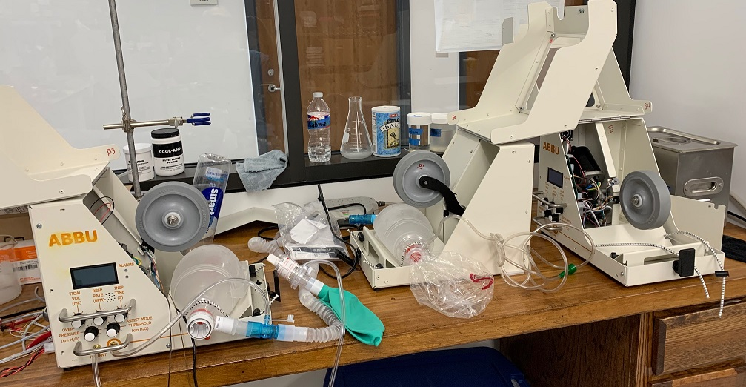

Electro-Thermal Bioinstrumentation Laboratory and Sponsor Opportunities
Embedded system design, Biomedical instrumentation, cardiac volume measurement using electrical fields, and bioheat transfer
Valvano's research papers
Measurements of pressure, cardiac volume, thermal properties, and blood perfusion. Also there is electrical and thermal modelling.
ASEE Workshop on IoT (wifi) slides Download materials as ASEE2015.zip June 2015
ASEE Workshop on IoT (BLE) slides Download materials as BLE.zip June 2016
ASEE Workshop on IoT (RTOS) slides Download materials as Valvano_TI_RTOS.zip June 2017
ASEE Workshop on Robot Systems Learning Kit slides Download the Android app More information on RSLK June 2018

EE385J.17/BME384J.2 Real-Time Embedded Instrumentation, last taught Spring 2009
Graduate lab class: Instrumentation and real time software. Prerequisites: Microcomputer interfacing, C, op amps, differential equations.

Four textbooks for learning embedded systems on the MSP432.
Introduction to Robotics (August 2020) ISBN: 978-1074544300 Available from Amazon This book could be used to accompany the Texas Instruments Robot Systems Learning Kit. This book, which is actually a composition of material from the following three books, teaches the fundamentals of microcontroller interfacing and real-time programming in a single book using robotics as the context.
Volume 1, Introduction to the MSP432 Microcontroller (January 2019) ISBN: 978-1512185676, Available from Amazon Volume 1 includes architecture, assembly language and C programming for the Texas Instruments MSP432.
Volume 2, Real-Time Interfacing to the MSP432 Microcontroller (July 2021), ISBN: 978-1514676585 Available from Amazon, Volume 2 includes interfacing, circuits, real-time systems and the internet of Things (IoT).
Volume 3, Real-Time Operating Systems for ARM Cortex-M Microcontrollers (fifth printing, January 2019), ISBN: 978-1466468863, Available on Amazon Lecture and Lab Material Operating systems, signal processing and network design for the Texas Instruments MSP432, TM4C123, and TM4C1294.
Embedded Microcomputer Systems: Real Time Interfacing, 3rd Edition, 2011, ISBN-13: 978-1111426255 Download all Teaching Materials
Textbook, Cengage Learning, Table of Contents, outline, extra questions, programs from the book, list of errors. 9S12 Starter files 9S12 boards/Metrowerks 9S12C32 programs
Introduction to Embedded Systems: Interfacing to the Freescale 9S12 Textbook, Cengage Publishing 2009, ISBN-10: 049541137X | ISBN-13: 9780495411376 Teaching materials Web videos of the Example lessons from the book Instructional Movies Table of Contents, Book errata, list of all errors
TExaS, Test EXecute And Simulate Hardware/Software Co-Simulator, integrated simulator including mechanical, electrical, digital and software components, used for designing embedded systems based on the Freescale 9S12 (UPGRADE to latest version). Instructional Movies Help System in Vista Help System in Windows 7
TExaS Robots version 1. 83b, a simulated battlefield for 50 9S12DP512-controlled robots (download the Trobots.zip file).
Developing Embedded Software in C Using Metrowerks, edited by Ramesh Yerraballi
On-line HTML textbook, overview of C programming for the 9S12
Example design solutions for embedded systems. Example files for the TI LM3S Microcontrollers Software and hardware solutions based on the Freescale 9S12 and the Texas Instruments LM4F120, TM4C123, and TM4C1294
Links to 6812 ICC12 C program examples
LED, LCD, RTI, OC, SCI, SPI, DAC, FSM, FIFO, PWM, threads, interpreter,
Developing Assembly Language Software using TExaS
On-line HTML textbook, overview of assembly programming for the 6811 and 6812
Introduction to Embedded Microcomputer Systems: Motorola 6811 and 6812 Simulation
Textbook, Thomson-Engineering, ISBN 0-534-39177-x, outline. Lectures, old exams, and other material

Architecture, Computer Systems, and Embedded Systems (ACSES) Advising
For Biomedical Engineering Advising contact Professor Soloveichik

